 | AMERICAN INTERNATIONAL UNIVERSITY-BANGLADESH (AIUB)  Department of Computer Science · Faculty of Science and Technology  DS 02449: Programming for Data Science · Fall 26–27 · Section: [A] · Mid-Term Project (Phase I)  Supervised by: MD. KAMRUL ISLAM
Name | ID
1. AMRIN SHERY KHAN | 24-59701-3
2. SADIA ISLAM NISHAT | 24-59774-3
3. ASRIN JAHAN IPSHITA | 25-61638-1
4. RIFAT JAHAN RIFA | 24-58964-2

1. Background Study
Plastic mulch film (PMF), mostly low-density polyethylene (LDPE), conserves soil moisture, regulates soil temperature and suppresses weeds, but it fragments in the field and leaves microplastics in the soil (Huang et al., 2020; Hurley & Nizzetto, 2018). Microplastics can change soil structure, water movement and microbial activity (de Souza Machado et al., 2018; Rillig et al., 2017). Many studies cover one region or one laboratory, so cross-country comparison is difficult. The dataset used here applies one survey protocol in five countries and includes an inter-laboratory comparison, which allows measurement reliability to be examined as well.

2. Problem Statement and Research Questions
Soil microplastic contamination is an emerging environmental concern because plastic particles can accumulate in agricultural soils and potentially affect soil quality and ecosystem functioning. Understanding its extent requires examining not only particle concentrations but also soil characteristics and the agricultural practices associated with each sampling location. This project examines variation in MP abundance across countries and soil depths, relationships with soil properties and reported farm practices, the polymers identified, and the reliability of the analytical measurements. We describe associations only: the data are observational and do not establish causation.
- RQ1. How does soil microplastic concentration vary across countries and soil depths (10, 20, 30 cm)?
- RQ2. What relationships exist between MP concentration and soil properties (pH, EC, NH4, NO3, DOC, PO4)?
- RQ3. What agricultural practices and plastic-related activities are reported, and how are they associated with MP contamination?
- RQ4. Which polymer types are most frequently identified, and does this reflect the reported LDPE mulch use?
- RQ5. How reliable and consistent are polymer identification and laboratory quantification results?

3. Dataset and Source
We use Graf, Chadwick & Jones (2026), Agricultural soil survey and inter-laboratory comparison of microplastics across China, Egypt, India, Sri Lanka, and Vietnam, 2022–2025, NERC EDS Environmental Information Data Centre, https://doi.org/10.5285/c0407da7-acd0-4f5f-a1f3-5516206ba787 (accessed 25 Oct 2026). It contains real, raw field and laboratory measurements in eight CSV files and is licensed under the Open Government Licence v3 (“Contains data supplied by UK Centre for Ecology & Hydrology”). The data contain no personal information and are not redistributed with our code.
Table 1. Raw files in the dataset
File | Rows | Cols | Content
surveympquantification.csv | 576 | 5 | MP counts per site (192) and depth (10, 20, 30 cm)
surveysoilproperties.csv | 576 | 9 | pH, EC, NH4, NO3, DOC, PO4
surveyquestionnaire.csv | 192 | 49 | Farm practices, plastic use, climate, soil texture
surveympidentification.csv | 6,851 | 5 | Polymer type and match quality per particle
standardmpquantification.csv | 188 | 4 | Inter-laboratory recovery trials (blank, spiked, unspiked)
standardpolymerid.csv | 1,440 | 5 | Reference polymer identification and match scores per laboratory
standardpolymerlibrarycomparisonuk.csv | 180 | 5 | Match scores across spectral libraries
laboratorymetadata.csv | 8 | 45 | Laboratory protocols (reagents, separation media, instruments)

4. Methodology
We used Python (pandas, NumPy, Matplotlib, Seaborn) in a Jupyter notebook. The files were read with latin1 encoding. The key column “Site Code” in the soil-properties file was renamed “Site”. The MP quantification and soil-properties tables were merged on Site, Country and Depth (576 rows), then joined to the questionnaire on Site and Country, giving a master table of 576 rows × 58 columns. Because MP counts are strongly right-skewed (0 to 42,550), we used medians, a log1p transformation for plotting, and Spearman rank correlation (ρ), which does not assume normality. All comparisons are treated as observational associations.

5. Data Understanding and Preprocessing
All numeric columns converted correctly and no values fell outside plausible ranges (e.g., pH 4.1–9.4, match quality ≤ 100). Table 2 summarises the issues found and our decisions.
Table 2. Data validation and preprocessing decisions
Issue | Observation | Decision and reason
Key names | “Site Code” vs “Site” | Renamed to Site so tables could be merged on a composite key
Missing MP counts | 4 Sri Lanka records (SL34 at 20 cm; SL36 at 10 and 20 cm; SL37 at 10 cm) | Left missing, not imputed, to avoid inventing values for the main variable
Missing DOC | 6 values (Sri Lanka), so n = 566 for DOC | Left missing; excluded pairwise in correlations
Questionnaire blanks | 656 empty cells, mostly in conditional fields (e.g., sludge, compost, coated-fertiliser details) | Mostly structural (no answer when the practice is not used); kept as NaN
Duplicate polymer rows | 236 of 6,851 (3.4%) | Flagged and kept, since they may be separate particles; removing them changes the polymer ranking only slightly (Rubber 32.3% vs 31.2%)
Extreme values | IQR rule flags 48 MP values; max 42,549.6 | Kept as likely real hotspots, not entry errors; used medians and log1p for plotting
Possible unit mix | Some EC values are 0.16–3.16, far below typical values | Flagged; to be checked against the supporting document before any modelling

6. Exploratory Data Analysis

6.1 Overall distribution, countries and depths (RQ1)
MP abundance (unit to be confirmed in the supporting document) is extremely right-skewed: mean 900.5, median 90.9, range 0–42,549.6 (Figure 1a). Differences between countries are large (Table 3, Figure 1b): Sri Lanka and Egypt have medians near 1,000, India and China are below 60, and Vietnam is near 4. By depth, medians are similar (84.4, 92.0 and 102.1 at 10, 20 and 30 cm) and the spread within each depth is far larger than the differences between depths (Figure 1c). MPs were therefore present at all sampled depths, but the data show no clear vertical pattern.
Table 3. MP number by country and depth (572 site-depth records with a count)
Group | n | Mean | Median | Std. dev. | Max
Sri Lanka | 116 | 3,136.7 | 1,110.9 | 5,931.9 | 42,549.6
Egypt | 120 | 1,122.7 | 974.4 | 711.4 | 4,212.0
China | 120 | 76.6 | 41.4 | 91.9 | 511.5
India | 96 | 69.6 | 59.5 | 42.9 | 228.6
Vietnam | 120 | 5.3 | 4.4 | 5.2 | 28.8
All records | 572 | 900.5 | 90.9 | 3,028.9 | 42,549.6
Depth 10 cm | 190 | 1,043.9 | 84.4 | 4,380.2 | 42,549.6
Depth 20 cm | 190 | 867.2 | 92.0 | 1,940.8 | 19,256.4
Depth 30 cm | 192 | 791.5 | 102.1 | 1,762.5 | 15,846.2

6.2 Soil properties (RQ2)
Spearman correlations with MP abundance (n = 572; DOC n = 566) are positive for NH4 (ρ = 0.595), DOC (0.541), NO3 (0.242) and pH (0.219), and negative for EC (−0.306) and PO4 (−0.412) (Figure 1d). These are associations across pooled countries. Because countries differ strongly in MP levels and probably in soil chemistry, part of each correlation may reflect country differences instead of a link within sites; the correlations have not yet been checked within countries.
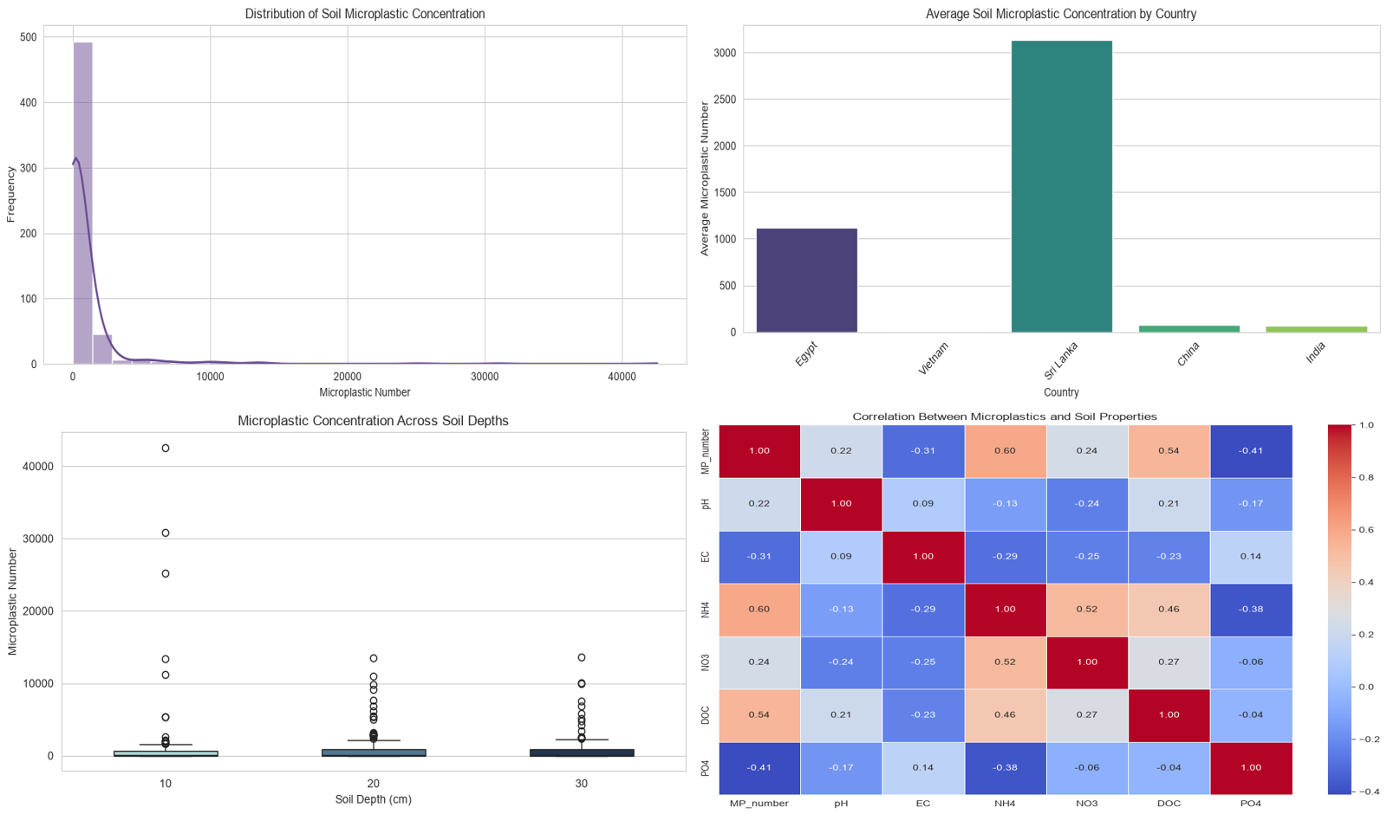

6.3 Agricultural practices (RQ3)
Figure 2 and Table 4 compare site-level mean MP counts between sites that report a practice and sites that do not (192 sites). Sites reporting irrigation pipes, packaging waste, polytunnels, coated fertiliser or compost have higher medians than sites that do not, while sites with nets or greenhouses have lower medians. These differences should not be read as effects of the practices: country differences are likely to affect every comparison, and nets and greenhouses appear mostly in Vietnam and China, where MP levels are low. Polytunnels (n = 5) and nets (n = 10) are very small groups, and no significance tests have been run yet.
Table 4. Median site-level MP number by reported practice
Practice | Yes (n) | Median if Yes | No (n) | Median if No | Ratio Yes/No
Irrigation pipes | 86 | 875.1 | 106 | 57.3 | 15.3
Packaging waste | 20 | 1,243.9 | 172 | 75.3 | 16.5
Polytunnels | 5 | 1,053.2 | 187 | 100.4 | 10.5
Coated fertiliser | 38 | 558.2 | 154 | 83.6 | 6.7
Compost | 146 | 270.7 | 46 | 52.4 | 5.2
Greenhouses | 23 | 43.9 | 169 | 126.7 | 0.35
Nets | 10 | 4.3 | 182 | 108.0 | 0.04
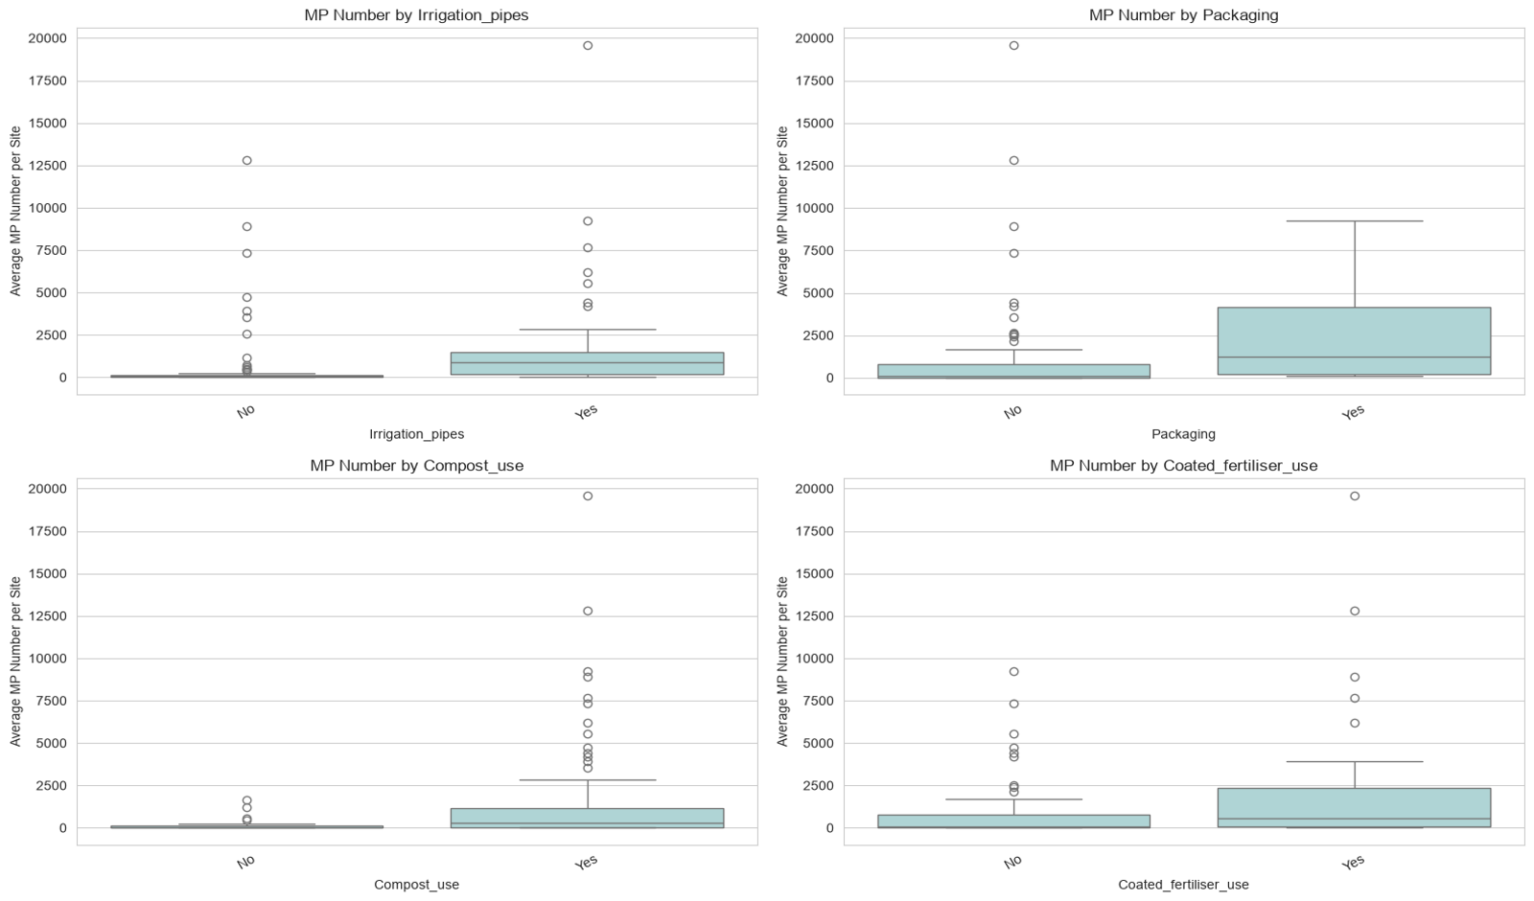

Figure 2. Site-level MP number with and without irrigation pipes, packaging, compost and coated fertiliser.

6.4 Polymer types (RQ4)
The 6,851 identified particles fall into 20 polymer classes. The most frequent are rubber (32.3%, n = 2,212), polyamide (30.1%, n = 2,064), PS (7.5%), PET (6.5%), PP (6.0%) and PE (4.8%, n = 330) (Figure 3). Although 188 of 192 sites (97.9%) report LDPE film, PE is a small share of identified particles. Possible explanations include other plastic sources, film breaking into particles too small to detect, or limits of spectral library matching. Our data cannot tell which explanation applies.
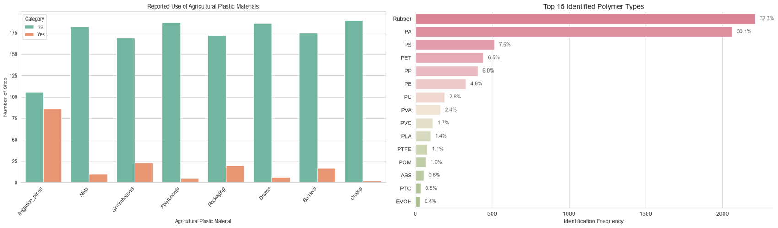
Figure 3. (Left) Plastic materials reported at survey sites; (right) the 15 most frequent identified polymer types.

6.5 Reliability and consistency (RQ5)
Library match quality for environmental particles averages 82.2% (median 83.2%, range 10.6–99.2%), so some identifications are weak. Average match quality is similar in Vietnam (85.6%), Sri Lanka (84.7%), Egypt (80.8%) and India (78.6%) but much lower in China (40.6%); we have not yet investigated why. The 236 duplicate rows barely change the mean match quality (82.19% with, 82.17% without). In the inter-laboratory recovery trials, spiked reference samples gave very different counts between laboratories (e.g., 205.2 in the UK laboratory vs 3,408.0 in Vietnam), which suggests that laboratory methods can shift measured values. The laboratory protocols differ (e.g., digestion reagents and density media), so this has to be tested formally.

7. Preliminary Findings
- MP abundance is highly skewed and differs strongly between countries, with country medians from 4.4 (Vietnam) to 1,110.9 (Sri Lanka).
- MPs occur at all three depths. Median abundance at 30 cm (102.1) is not lower than at 10 cm (84.4), but the spread is large and no test has been run, so we cannot describe a vertical trend.
- Soil chemistry is associated with MP abundance: NH4 and DOC positively, EC and PO4 negatively. These associations may partly reflect differences between countries.
- Sites reporting irrigation pipes, packaging waste and coated fertiliser have higher median MP counts, but country confounding means no practice can be called a cause.
- The polymer mix is not dominated by PE. Rubber and polyamide dominate identified particles, even though almost all sites report LDPE film. The reason is not established by our data.
- Measurement reliability is uncertain. Match quality varies widely and recoveries differ between laboratories, so laboratory method should be treated as a possible confounder.

8. Limitations and Next Steps
Limitations: (a) each country was analysed by different laboratories with different methods, so geography and laboratory are confounded; (b) the design is observational, so no causal conclusions are possible; (c) some practice groups are very small and no significance tests were run; (d) the unit of MP_number and the meaning of the Z column are still to be confirmed, and some EC values may use different units; (e) practices are self-reported; (f) polymer match quality varies.
Next steps: analyse each country separately; compare groups with Kruskal–Wallis and Mann–Whitney tests and effect sizes; fit a regression or mixed-effects model on log-transformed MP counts with country (and laboratory) as grouping factors; use the inter-laboratory files to quantify laboratory differences; confirm the units; and relate the findings to Bangladesh cautiously, since the survey contains no Bangladeshi sites.

9. Reproducibility, Ethics and Team Contributions
All steps (loading, validation, preprocessing, analysis, figures) are in soil_microplastic.ipynb. The code, README and dataset information are in the project repository: [GitHub link]. The data are public under the Open Government Licence v3, attribution is given above, and we found no personal identifiers in the variables used. No values were fabricated or imputed. We confirm that this report is our own work.
Member | Contribution
Amrin Shery Khan | Problem definition and research questions; background study; report writing
Sadia Islam Nishat | Dataset search, source and licence verification; data loading and inspection
Asrin Jahan Ipshita | Data validation and preprocessing; merging; preprocessing decisions
Rifat Jahan Rifa | Exploratory analysis and visualisation; interpretation; README and repository

References
de Souza Machado, A. A., Lau, C. W., Till, J., Kloas, W., Lehmann, A., Becker, R., & Rillig, M. C. (2018). Impacts of microplastics on the soil biophysical environment. Environmental Science & Technology, 52(17), 9656–9665. https://doi.org/10.1021/acs.est.8b02212
Graf, M., Chadwick, D. R., & Jones, D. L. (2026). Agricultural soil survey and inter-laboratory comparison of microplastics across China, Egypt, India, Sri Lanka, and Vietnam, 2022–2025. NERC EDS Environmental Information Data Centre. https://doi.org/10.5285/c0407da7-acd0-4f5f-a1f3-5516206ba787
Huang, Y., Liu, Q., Jia, W., Yan, C., & Wang, J. (2020). Agricultural plastic mulching as a source of microplastics in the terrestrial environment. Environmental Pollution, 260, 114096. https://doi.org/10.1016/j.envpol.2020.114096
Hurley, R. R., & Nizzetto, L. (2018). Fate and occurrence of micro(nano)plastics in soils: Knowledge gaps and possible risks. Current Opinion in Environmental Science & Health, 1, 6–11. https://doi.org/10.1016/j.coesh.2017.10.006
Rillig, M. C., Ingraffia, R., & de Souza Machado, A. A. (2017). Microplastic incorporation into soil in agroecosystems. Frontiers in Plant Science, 8, 1805. https://doi.org/10.3389/fpls.2017.01805

